Asimov The New Hugo Winners, Volume II Baen Publishing 1991. As new dust jacket unclipped but no price. As new book with all 305 pages tightly bound with no marks of any kind. Art by Bob Eggleton
ID 000179 Price $14.95 Box 2

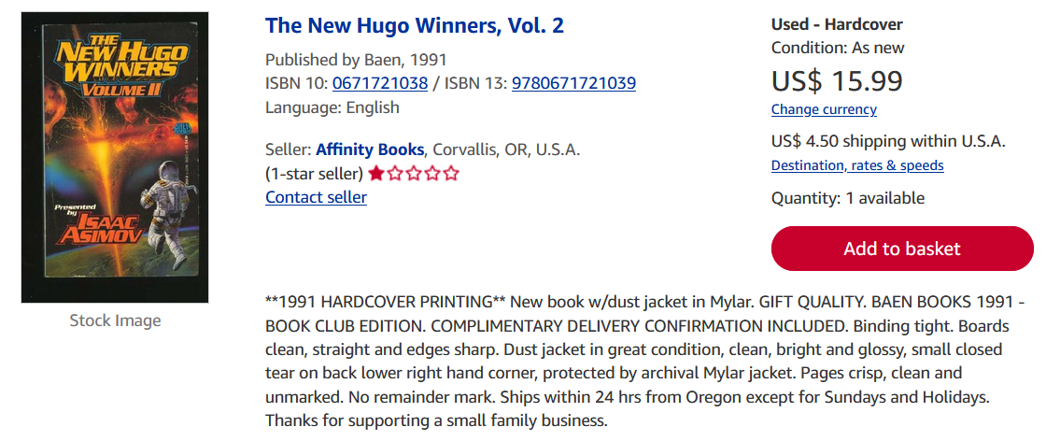
Abe Books

